Mechanics of Flexible Structures and Soft Robotics Homework 2
Luke Sage
Task 1

Based on scripts from lecture 06 [1], a new script has been written to model the deformation over time of the beam at the specified condition. Parameters are as follows: The beam is simply supported, constrained by a pin joint on the left, and a roller joint on the right side. The beam is a hollow circular tube, with inner radius 0.011m and outer radius 0.013m. The beam has a length of 1m and a density of 2700 kg/m^3. A load is applied to the beam at 0.75m from the left side of the beam. Fig. 1 shows the displacement after 0.8s, well after the beam has settled oscillation.

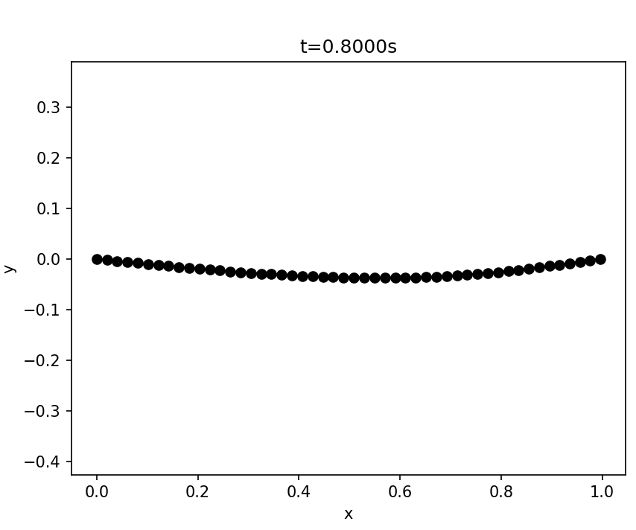
Fig. 1: Plot of the beam at T = 0.8s

The position of the lowest node in the Y direction was plotted over time as shown in Figure 2.

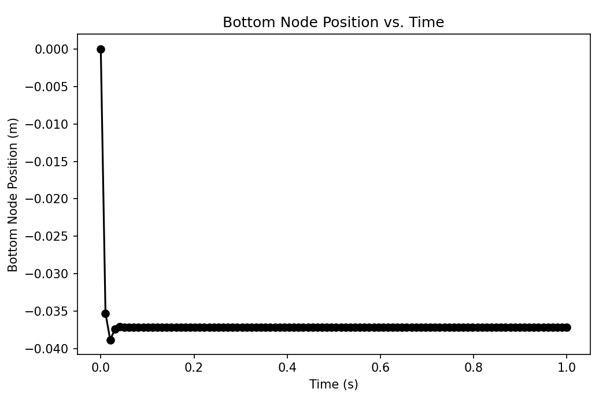
Fig. 2: Lowest node position over time

As shown in Figure 2, the minimum y value (the position of greatest displacement) quickly reaches a steady value. The oscillation effect comes from the numerical damping effect of the explicit Euler method, as viscous damping is neglected.
The maximum displacement calculated by the simulation is -0.0371m. The theoretical calculation based on the Euler beam bending equation provided in the assignment provided a maximum displacement of -0.0380.

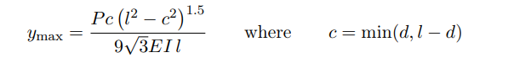

Comparing the two methods of calculation maximum displacement, there is a percent difference of 2.4%. This indicates a high level of accuracy at this range of force values. As the next task will touch on, as the assumption of small deformation becomes a poor simplification, the accuracy of the Euler beam bending equation will decrease.

Task 2

The simulation presents an advantage over the standard beam theory. Euler beam theory assumes no small deformation, and no displacement in the x direction. At higher load levels, large deformation will occur, and the assumptions that make the Euler beam theory work begin to become invalid. To validate this, a solution to the minimum node y position was calculated with both beam theory and based on the simulation. For the simulation, the beam is assumed to be fully at rest at a time of 0.5s. Figure 2 shows the time sensitivity of the beam’s bending, and indicates that the beam is largely settled before t=0.2s.
Figure 2 shows the deviation of the Euler beam bending from the simulation.

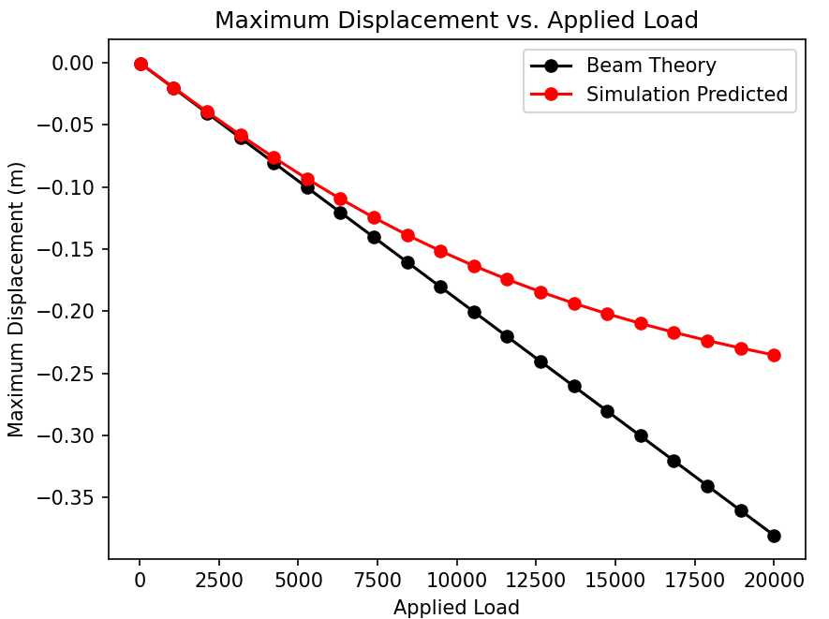
Fig. 2: Plot of test

At lower loads of less than 6000N, the displacement curves are very similar. As the loads increase, the beam theory approximation becomes less and less accurate. At the 20,000N mark, the percent difference is 47.1%, making the beam theory calculation not accurate.

- “25F-MECH&AE-263F-LEC-1 Mechanics of Flexible Structures and Soft Robots,” M. Khalid Jawed [Online]. Available: https://bruinlearn.ucla.edu/courses/216502.

